HOE MATARIKI 2023
Merchandise
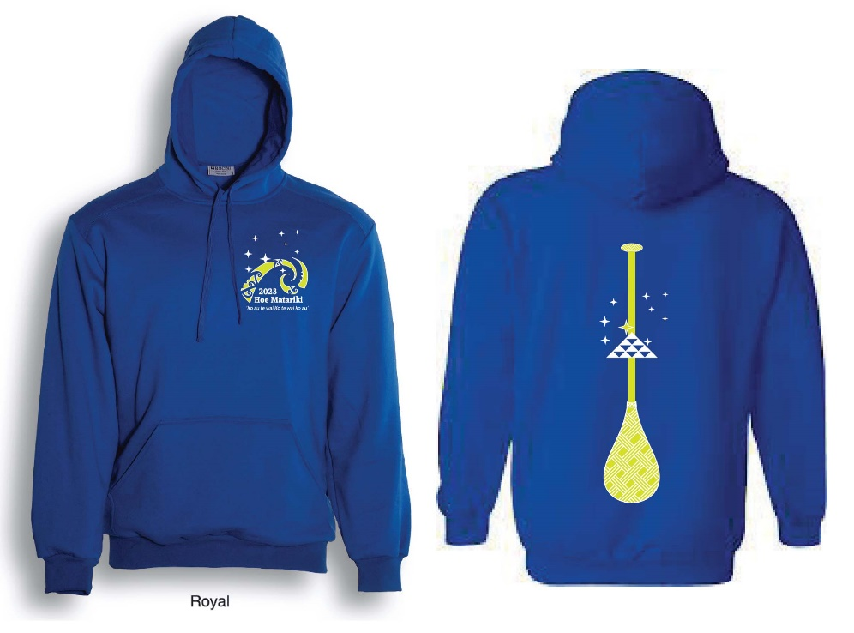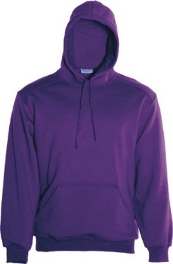
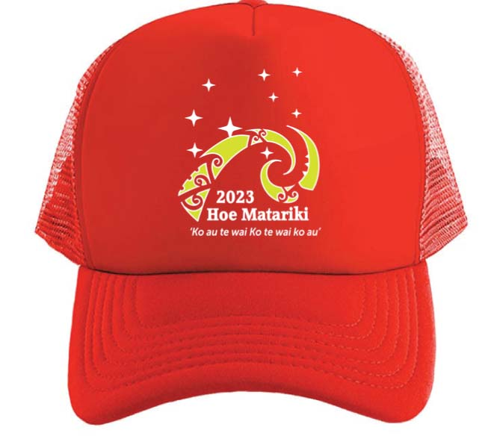Front Back Cap
HOODIE SIZE GUIDE:
SIZE(cm):
Measurement | XS | S | M | L | XL | 2XL | 3XL | 5XL
FullChest | 110 | 115 | 120 | 125 | 130 | 135 | 140 | 150
Length(Top Shoulder Point) | 66.5 | 69.5 | 72 | 74.5 | 77 | 79.5 | 82 | 87
*Option: Choice of Royal Blue or Purple hoodie printed with logos.

**This brand of hoodie is smaller fitting and would recommend upsizing if in doubt.
ORDERING
HOODIE | COLOURS AVAILABLE | SIZE | PRICE
Adults Unisex Pullover Hoodie  Polyester / Cotton Fleece With Anti Pill Fabric , With Cotton Jersey Lined Hood | Royal Blue  Purple | XS, S, M, L, XL, 2XL, 3XL, 5XL | $70 + pp
Trucker Cap | Red | OSFA | $20
Pre orders are to be paid in full prior to pick up on the day of event.  Please arrange someone to collect for you if your plans change.  There will be NO orders taken on the day. |  |  | Order Deadline:  25th June 2023

Please email your order to sharonthompson420@hotmail.com Name, number of items, colour selection (hoodies), phone contact and address if applicable.
Money to be deposited into Club account:
Bank Details:
Parihaka Waka Ama Inc
38-9015-0805080-00
Please put MERCH in code box & NAME in reference box.

